**Create a canvas app from scratch based on Excel data**

Create your own canvas app from scratch based on Excel data, formatted as a table, and then add data from other sources if you want. By following this tutorial, you'll create an app that contains two screens. On one screen, users can browse through a set of records. On the other screen, users can create a record, update one or more fields in a record, or delete an entire record.

## Connect to a data source

To connect to a data source, use the following procedure:

1. Download the [Flooring Estimates workbook](https://az787822.vo.msecnd.net/documentation/get-started-from-data/FlooringEstimates.xlsx) and save it to OneDrive for Business.
2. Go to [https://make.powerapps.com](https://make.powerapps.com/) and sign in with your organizational account.
3. In the left pane, select **Apps**.
4. Select **+ New app** and then **Canvas** from the drop-down menu.
5. For the **OneDrive for Business** data source, select **Phone layout**.

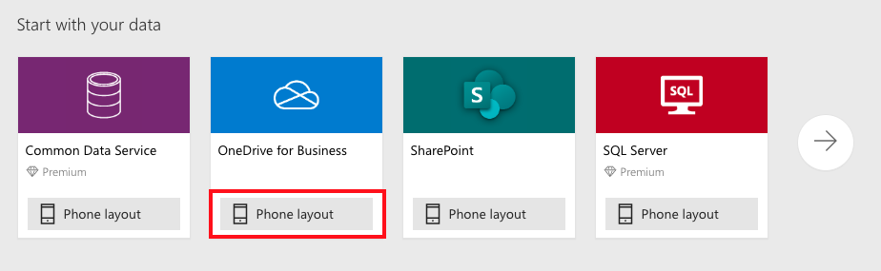

Generated apps are always based on a single list or table, but you can add more data to the app later. The next three steps explain how to connect to the Excel workbook.

1. Under **OneDrive for Business**, select **Create**.
2. Under **Connections**, select **OneDrive for Business** and browse to the file location. You might need to select **New Connection** to see the **OneDrive for Business** connection.
3. Under **Choose an Excel file**, select the **FlooringEstimates.xlsx** file.
4. Under **Choose a table**, select the **FlooringEstimates** table.
5. Select **Connect** on the bottom right.

## Explore the generated app

Your new three-screen app now opens in Power Apps Studio.

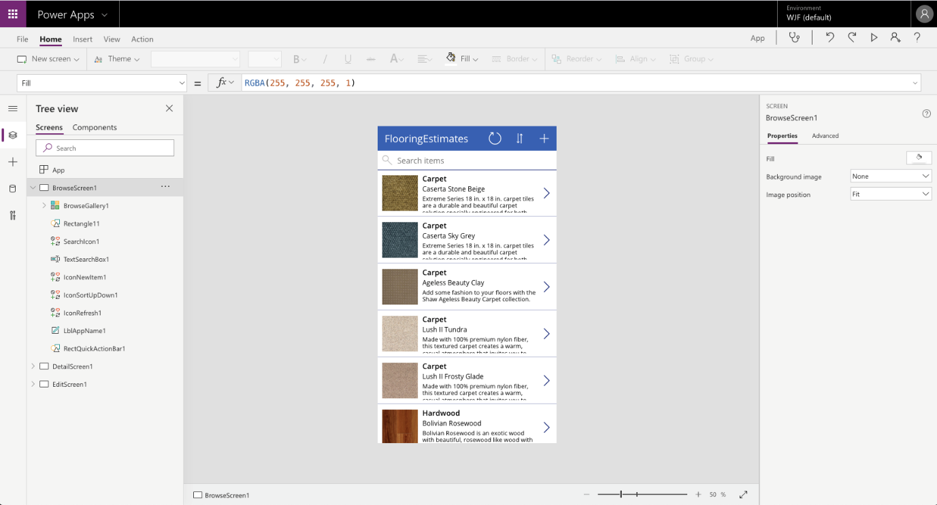

Select **Play**  in the upper-right corner to practice using the app.